

**Full Stack Web Development Internship Program**

**(EDUREKA)**

**STAYBNB**

Name: Nisha Prabhakar khare

**Overview:**

A stay bnb is a online marketplace that connects people who want to rent out their homes with people who are looking for accommodation in specific locales.

**First page of website**

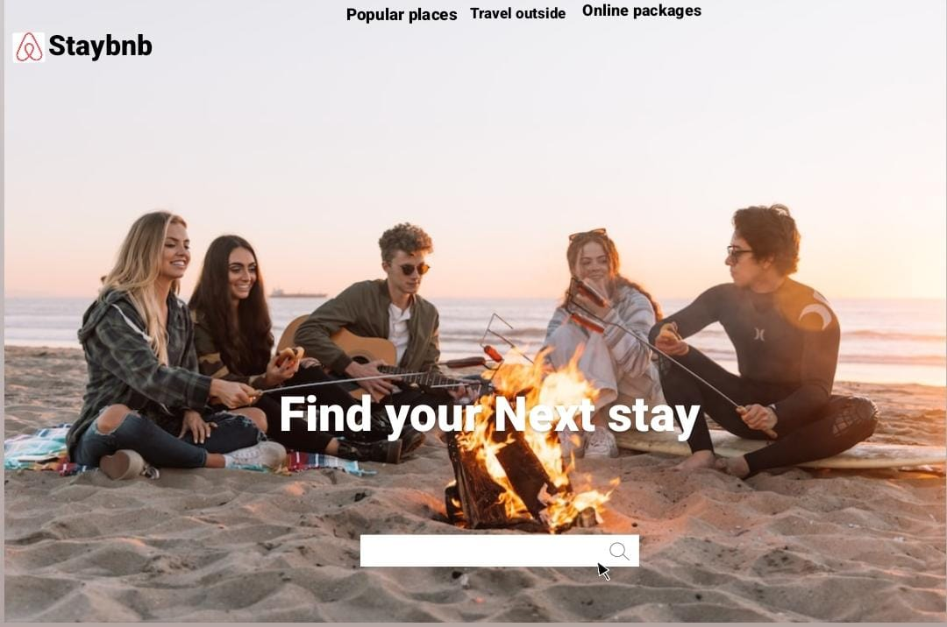

**1.HOME PAGE:**

* SLIDER IMAGE WITH ARROW & AUTO (IMAGES)
* LOGO
* ICONS -
* SEARCH BAR
* CHECKIN
* CHECKOUT
* SIDE - (IMAGES)
* EXCLUSIVE PLACES(IMAGES)
* TRENDING PLACES - (IMAGES)
* TRAVELLER STORIES
* FOOTER – ( CONTACT US , HELPLINES , BRIEF DESCRIPTION ABOUT THE COMPANY , SOCIAL-MEDIA HANDLE ICONS)

**2. Navigation bar (on top)**

* Company name
* Avatar button (registernow)
* Popular places
* Travel outside
* Online package

**Second page of website**

**3. Menu bar**

AS we click on popular places list of house will open and we can choice from there

**4. Filters**

* Shopping mall
* Near mountain
* Near beach

**Third page of website**

Details information about listed page some descrption Prize and location map information of user how have posted this house on this website

**5.PAYMENT PAGE**

* ADDRESS SELECTION
* PAYMENT METHOD - (PHONEPE , GOOGLE PAY , BHIM UPI , COD , CREDIT/DEBIT CARD , NET BANKING , EMI , PAYTM)

**Home page details**

**Popular place**

**Travel outside**

**Online package**

LOGO NAVAGATION BAR MENU

Travellers stories

BACKGROUND IMAGES

Search bar location

BAC

Trending places

EXCLUSIVE PLACES

CATEGORY